**FOLDING CARTON ESTIMATING OPTIONS**

**Cad Integration for Esko Artios**

1. Advantzware imports data and link to images generated by the ArtiosCAD system.
2. Integration activated when the user elects to create a new estimate.
3. Prompts for the file path and name of the .ard file, quantity, category and style information from the user.
4. Automatically displays a list of forms in the ArtiosCAD file, allowing ASI user to specify blank information.
5. Advantzware pulls the new estimate information from the specified ArtiosCAD file, via CADx.
6. Process generates box image .jpg files, place them in the proper directory, and add a link to the image to the new Advantzware estimate.
7. New images can be added to the job tickets that Advantzware creates.

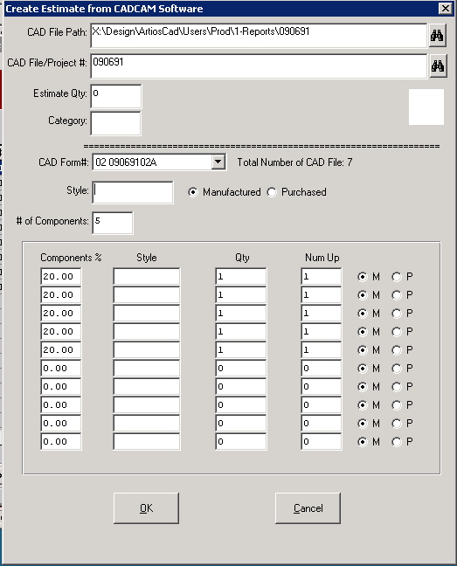

**FOLDING CARTON ESTIMATING ICONS - Single Item Estimate 1416**

Help Menu - To expand Estimating Screens Immediately when accessing.



Job Transfer Icon to Transfer Actual Production MR, Run and Waste to the Estimate.  
This will generate more accurate estimates and better machine scheduling for Repeat Jobs.



Excel Icon allows users to create custom reports and will transfer estimate data directly to excel file.



Column Icon allows each user to move, reduce and expand data columns.



Fountain Pen houses typed notes by for specific machine department for this specific estimate.  
Indicates that notes exist for this item. Icon is identical to item file, orders and jobs.  
  


Paper Clip to Attach Files to the Specific Estimate and Job. Yellow Background indicates data exists.



Book Icon for Finished Goods Item Specific Notes follows all Estimates. Yellow Background Indicates that notes exist for this item. Icon is identical to item file, orders and jobs.



Double Computer Icon allows defning user specific menu for fast access to utilities or programs.



Question Mark is used for screen sensitive help. F3 key is used for field sensitive help.



Circle of Arrows will sort the list of estimates ascending and descending.



Sigma show decimal to fraction chart.

**FOLDING CARTON ESTIMATING - Estimate Browser**

1. **Search Fields:** Find Estimates by Estimate, Customer, Shipto, FG item, FG Item Description, Customer Part#, Length, Width, Depth, Die#, Cad# and Plate#.
2. **WildCard Searches:** Find Estimates by a string of text utilizing the * key * to initiate the wild card search. Note that I search for *Turtle* and it finds all estiamtes that includes that string of letters.
3. **Expand Screen:** Set the expansion permanently via the Help Menu or as needed via the Icon.
4. **Column Manipulation:** Move Columns, Reduce Columns, Remove Columns or Expand Columns by User ID.
5. **Single Item Estimates**
6. **Two Piece Boxes**
7. **Tandem Jobs**
8. **Combination Jobs**
9. **Farm Out Purchased Boxes**
10. **Laminating Printed Sheets to Single Face**

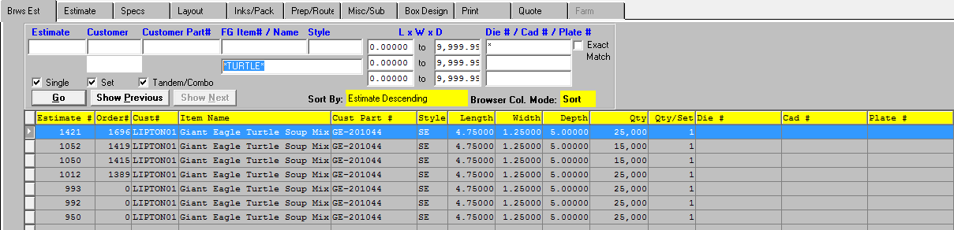

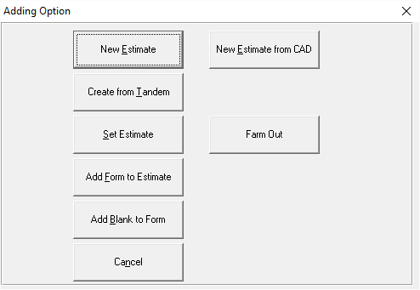

**FOLDING CARTON ESTIMATING - Estimate Tab Single Item Estimate 1416**

1. Mandatory Fields: Cust#, Shipto, Part#, Quantities, Style, Length, Width, Depth.
2. Program calculates: Spec Tab, Layout Tab, Inks/Pack Tab, Misc/Sub Tab, Box and Box Design Tab.
3. F1 On Quantity Tab allows for Up to 20 estimate quantites which feed PRINT tab Calculate Button.
4. Purchased/Manf Field for Buyouts
5. N-K-1 CEFGITEM to changes color of FG Item code on estimate tab for Inactive Items. Estimate 1389.
6. Purchased/Manf Field for Purchased Finished Goods via Farm Tab Costs by Vendor.
7. Shipto Code automatically populates PACKS tab
8. Number of Colors automatically Populates INKS Tab
9. Postive Qty per Set is Multiplied By Estimate Quantity
10. Negative Qty per Set is Divided By Estimate Quantity
11. **GOTO Button** for Gang Jobs

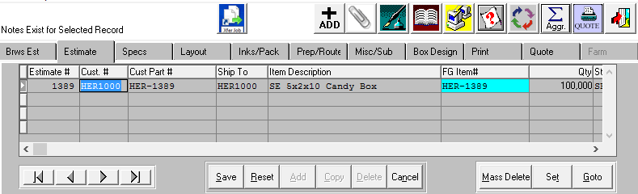

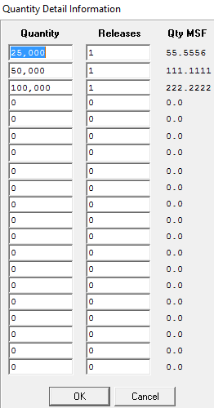

**FOLDING CARTON ESTIMATING - Spec Tab Single Item Estimate 1416**

1. TEMP Customer for Prospective Clients.
2. Drill Down Buttons: Cust#, FG Item#, Style Code and Board Code.
3. Override Button to change blank length or width.
4. Binoculars to Import Die# and Cad# (N-K-1 DieFile and N-K-1 CadFile)
5. AutoCalc Button will calculate blank length and width based on style file formulas.

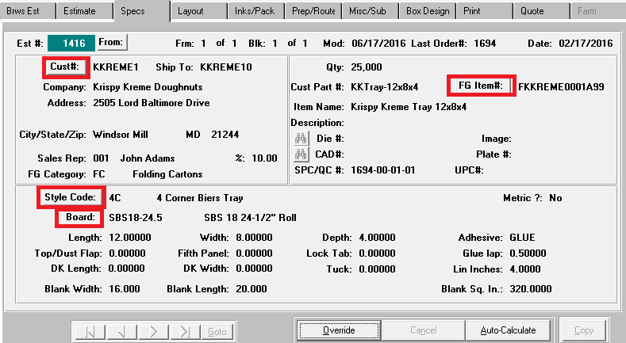

**FOLDING CARTON ESTIMATING - Spec Tab Single Item Estimate 1416**

1. N-K-1 AddPrep to automatically create add plate and die file.
2. N-K-1 PREPMASTER for defaults Character Value: [Mattype]=[PrepCode.
3. N-K-1 PREPDIEBIN, PREPDIEGL, PREPPLBIN, PREPPLGL settings.

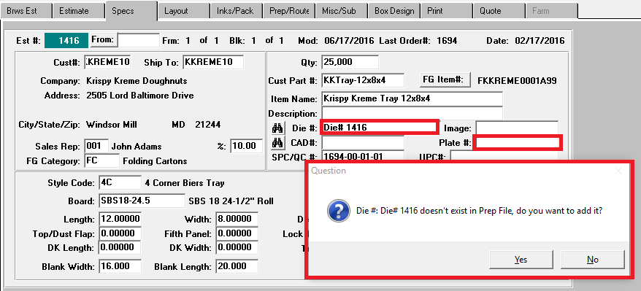

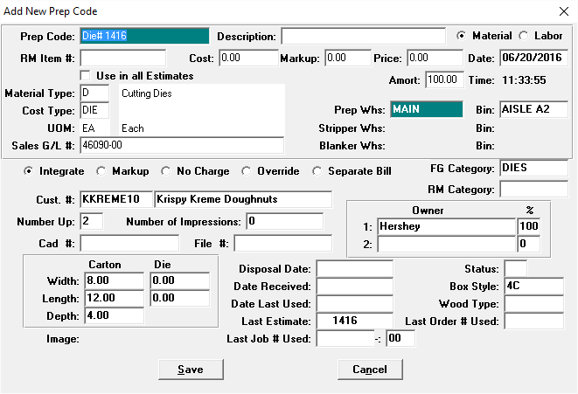

**FOLDING CARTON ESTIMATING - LAYOUT Tab Single Item Estimate 1416**

1. AUTO CALC Button to calculate Die and Sheet Size via Style Formulas with Layout Machine Limits.
2. OVERRIDE Button to manually enter Die and Sheet Sizes
3. SHT CALC Button for searching Best Fit Sheet or Roll for calculated Die Size.
4. JOB STNDS Button to transfer Layout Tab changes to Open Job in Job File.
5. Board Button to Drill Down to raw materials file.
6. N-K-1 CERoute and CERouteFC as Default Machine for calculating Die and Sheet Size.
7. Cost/ field to Override Cost by Ton, MSF, LB, MSH
8. Xgrain to calculate by Normal Grain, Blank Cross Grain or Sheet Cross Grain.
9. Freight/ to override Cost for Freight for Board
10. NC to set board cost = NO Charge or Chargeable
11. Die # On to calulate Die Size knife for knife and Machine Feed with Trim.
12. Machine Feed for # out on Guilotine after Printing
13. Gross Sheet for Sheeter Size and #Out if Slitting on Sheeter.

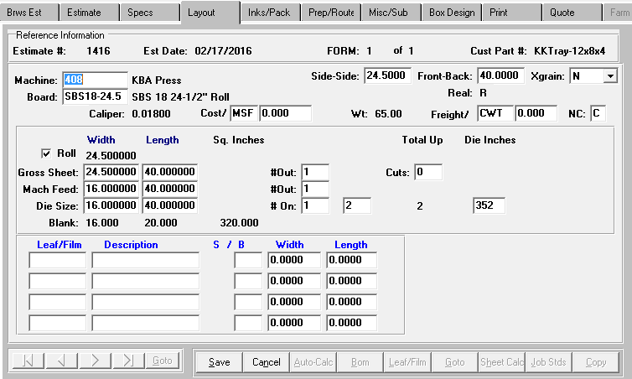

**FOLDING CARTON ESTIMATING - LAYOUT Tab Single Item Estimate 1416**

**SHT CALC Button to pick stocked sheets or rolls for the Job.**

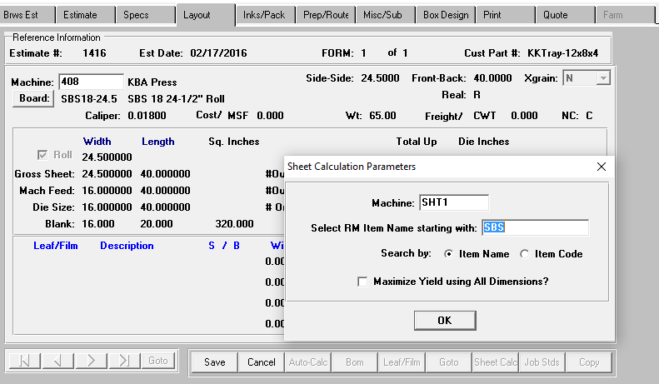

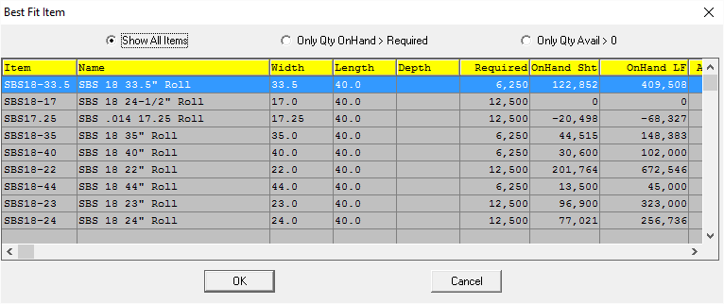

**FOLDING CARTON ESTIMATING - INKS/PACK Tab Single Item Estimate 1416**

1. Quote Description transfers from Inks Tab Description field.
2. RESET INK to set Ink Type from Style File or Estimate Control File to import Offset or Flexo inks.
3. Inks Prompt to transfer to ALL Existing Estimates for same Customer Part#.
4. N-K-1 FGColors allows changing the colors in Finished Goods to update Estimate Inks.
5. Unit# of Fountain will print on customized Job Tickets.
6. Front / Back Side Printing will print on customized Job Tickets.

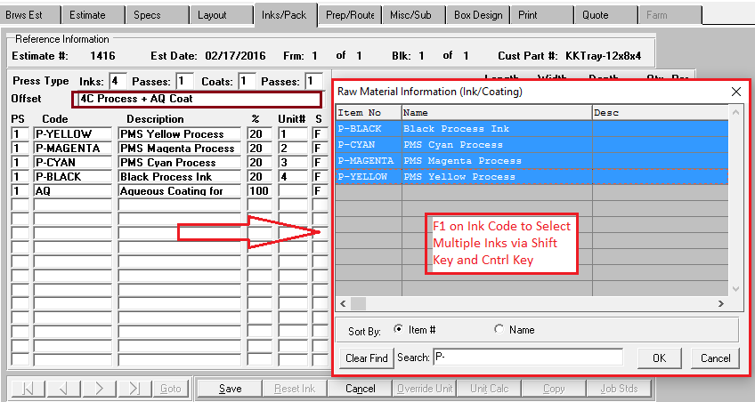

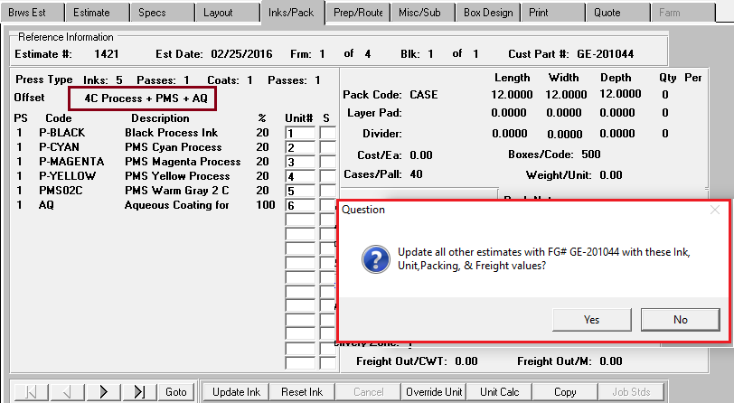

**FOLDING CARTON ESTIMATING - INKS / PACK Tab Single Item Estimate 1416**

1. Packing Note will transfer to O-U-7 Load Tag perhaps to load Specific Color Labels
2. COPY Button prompts to transfer to Inks, Packing and Freight to existing estimates for same Part#.
3. JOB STNDS Button to copy changes to open jobs in the Job File.
4. Layer Pad and Case Dividers by Case or by Pallet

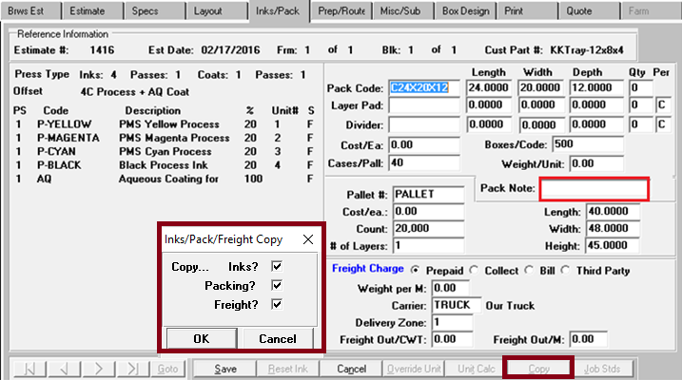

**FOLDING CARTON ESTIMATING - PREP / ROUTE Tab Single Item Estimate 1416**

1. NK1 CEROUTEF will automaticaly route machines when adding new estimates.
2. SIMON codes for biling and cost options of Plates, Dies and Prep by Form and Blank Number
3. Estimate Run Qty matrix for unique machine routing by Estimate Quantity.
4. ADD Button to Add machine and Import MR, Run and Waste numbers from Machine File.
5. ADD STDS Button to Add machine and Manually Enter MR, Run and Waste numbers
6. IMPORT Button to import MR, Run and Waste numbers from Machine File.
7. IMPORT Button to Enter Number of Color Changes and Fountain Changes
8. OVERRIDE Button to Manually Enter MR, Run and Waste numbers
9. BUILD button to rebuild machine routing.
10. COPY button to Copy MR and Run Speeds from 1 Form to Other Forms.

**Multiple Routing Options by Quantity   
Note that Hand Stripping is Included for eatimate quantities of up to 100,000.**

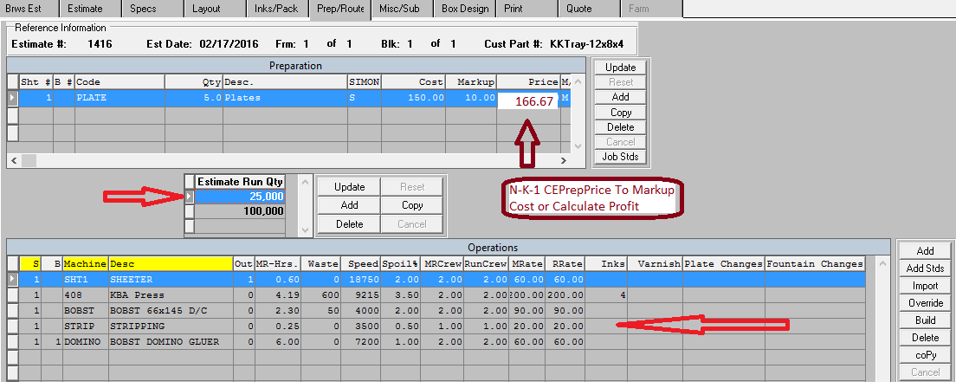

**Multiple Routing Options by Quantity   
Note that Hand Stripping is Excluded for estimate quantities of 100,000 and greater.**

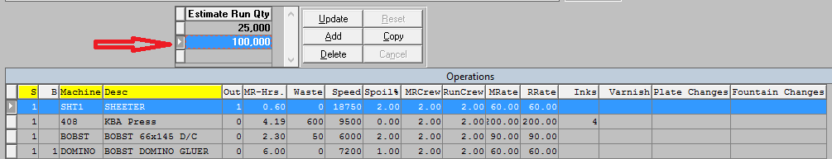

**FOLDING CARTON ESTIMATING - PREP / ROUTE Tab Estimate 1420**

1. Job Xfer Button Downloads Actual Data Collection back to Estimate.
2. Job Xfer Button improves Schedule Board times for Repeat Jobs.

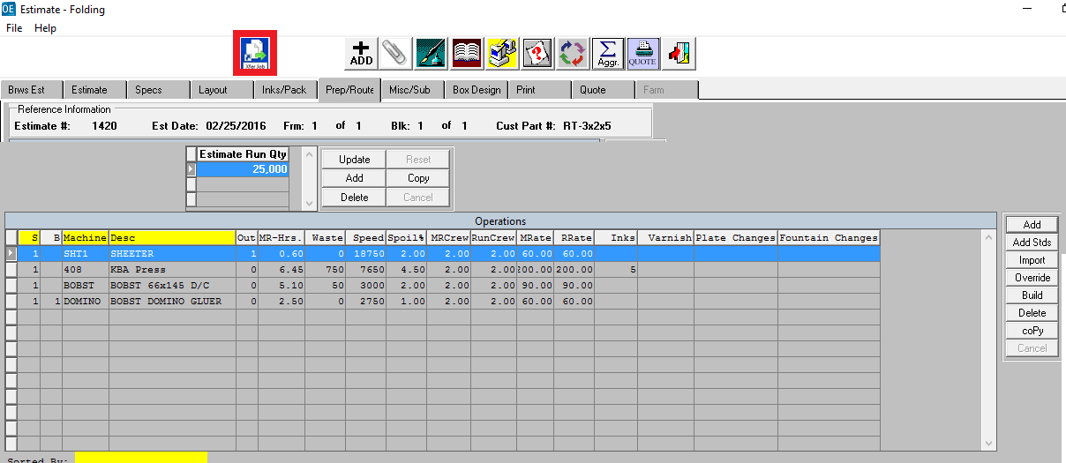

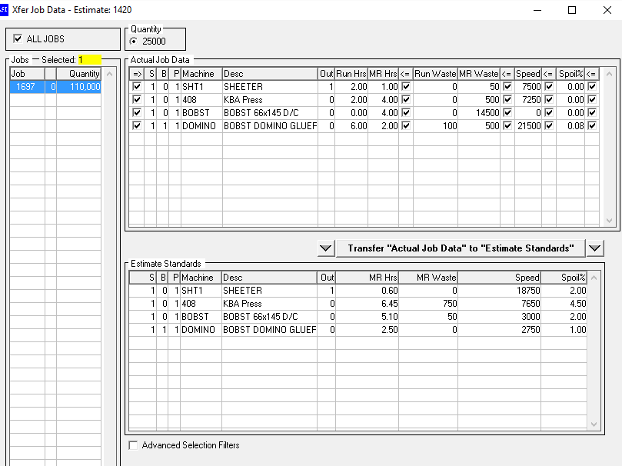

**FOLDING CARTON MISCELLANEOUS / SUB-CONTRACT GENERAL FEATURES**

1. Manually Typed Outside Costs for Labor or Material
2. Lookup Materials predefined in Raw Materials File
3. Quantity per Set multiplied by Estimate Quantity

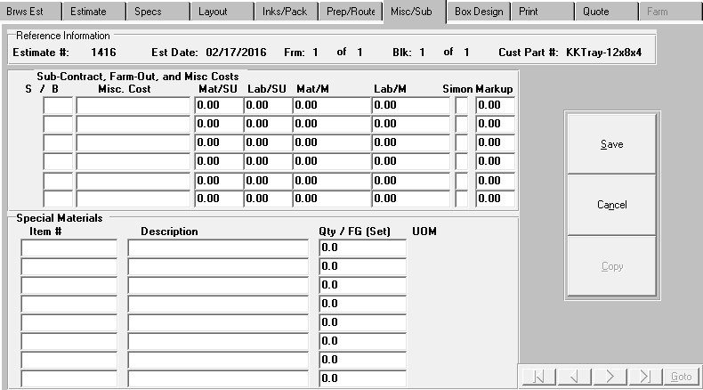

**FOLDING CARTON BOX DESIGN GENERAL FEATURES Box Design Tab**

1. Box Design transfers from Box Design File via Style File
2. Manually Import Cad Image from Adobe Illustrator, Paint, Photoshop, etc.
3. Spec Tab Cad Binocular Icon Transfers to Box Design Cad/2D Image
4. Spec Tab Die Binocular Icon Transfers to Die Image
5. 3D Image Transfers from Style / Box Design
6. Graphics .PDF image tied to Finished Goods Item

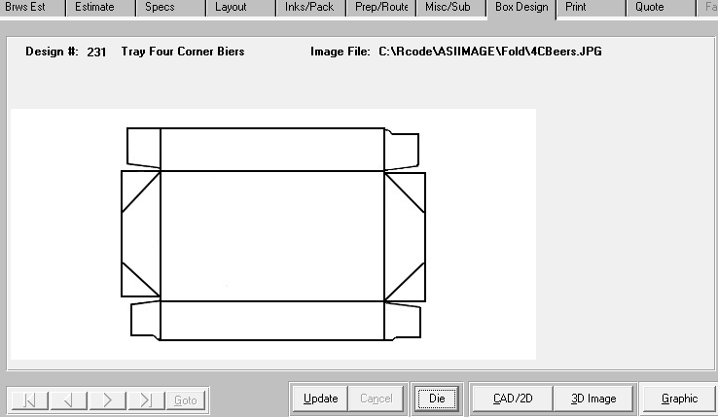

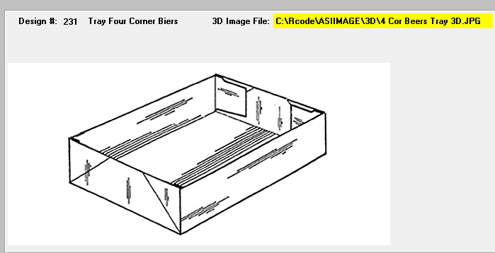

**FOLDING CARTON ESTIMATING - PRINT Tab Single Item Estimate 1416**

1. Purge / Append Buttons when calculating Estimate
2. NK1 CEDefault, NK1 CERUN and NK1 CEGS&A for Default Print Calculations
3. Whatif Button to change price by Gross Profit, Net Profit or Sell Price.
4. Q field to transfer Quantity and Price to Quote File
5. Import Button to import Older Quoted Prices to New Estimate Sell Price
6. Selling Prices are calculated via Control File based on Gross or Net Profit Markup
7. NK1 CE Round to round selling price to Dollar or Penney.
8. NK1 CEPREP to round selling price of billable prep.

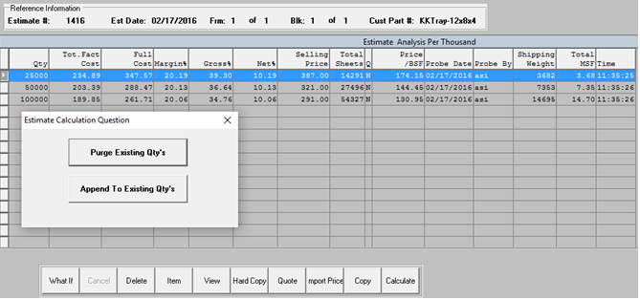

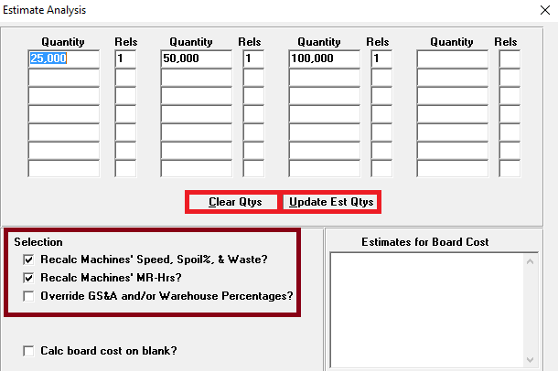

**FOLDING CARTON ESTIMATING - PRINTOUT OPTIONS Single Item Estimate 1416**

1. HardCopy Options to Limit Estimate Print Out.
2. Detailed Pricing per Quantity and Totals for One Quanitty
3. Detailed Pricing per Quantity and Up to Five Quantity Summary
4. Emailing

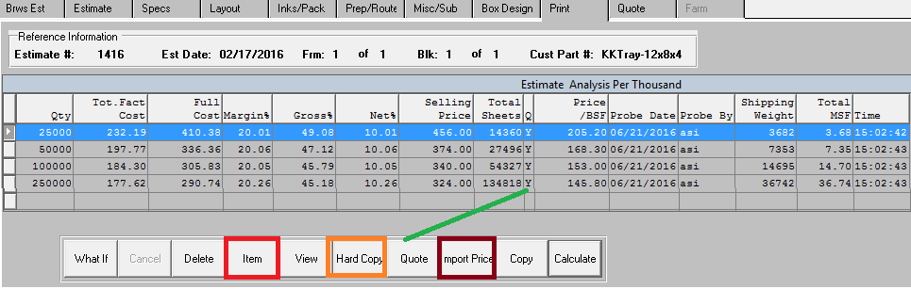

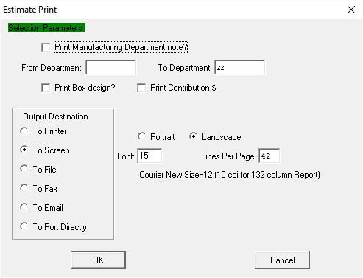

**FOLDING CARTON ESTIMATING - N-K-1 CERUN PRINT OPTIONS Estimate 1416**

**Special Markups: Control File, NK1-CEMISC, NK1-CEMat’l, NK1-CEBoard, NK1-CEVendor**

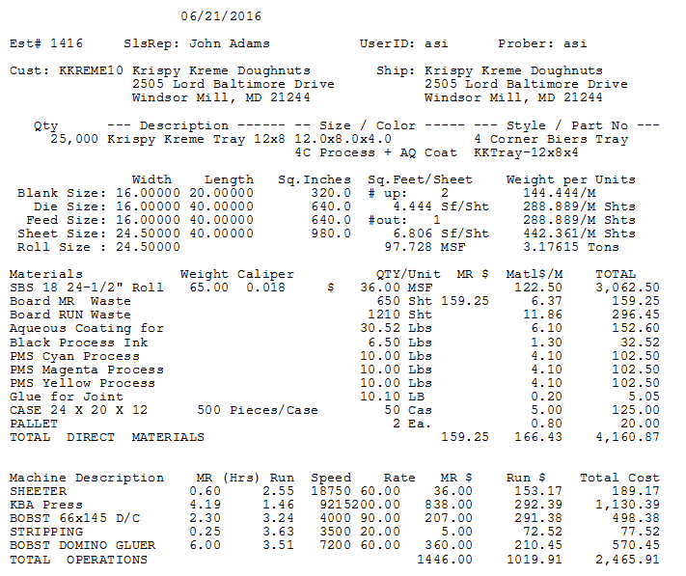

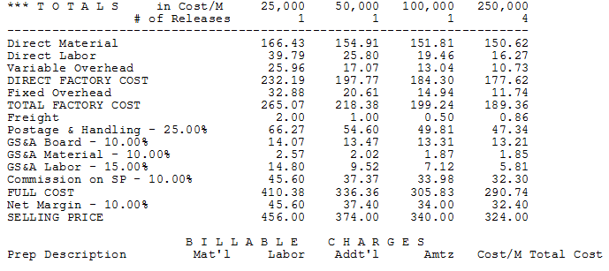

**FOLDING CARTON ESTIMATING - QUOTE Tab Single Item Estimate 1416**

1. Estimate Specs and Pricing Transfer to Quotes by Customer as EA or M via NK1 QuoPrice .
2. Quotes Purge / Append Buttons when calculating Estimate
3. View Quote Tab to Modify Item and Board Descriptions
4. NK1 QuoteNote houses the Quote number for Quote Notes to transfer to New Quotes.
5. NK1 QuoPrice - Browse Form for Unique Price Unit of Measure by Customer

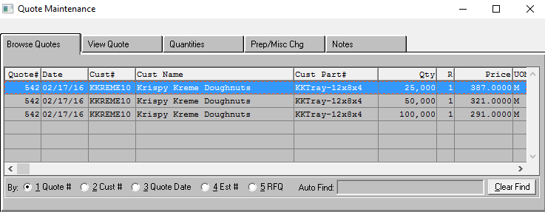

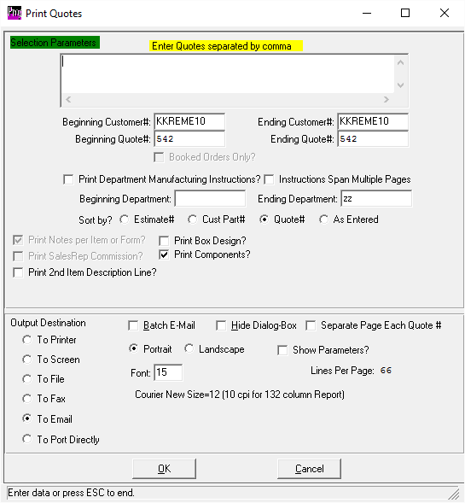

**FOLDING CARTON ESTIMATING - EMAILING QUOTES Estimate 1416**

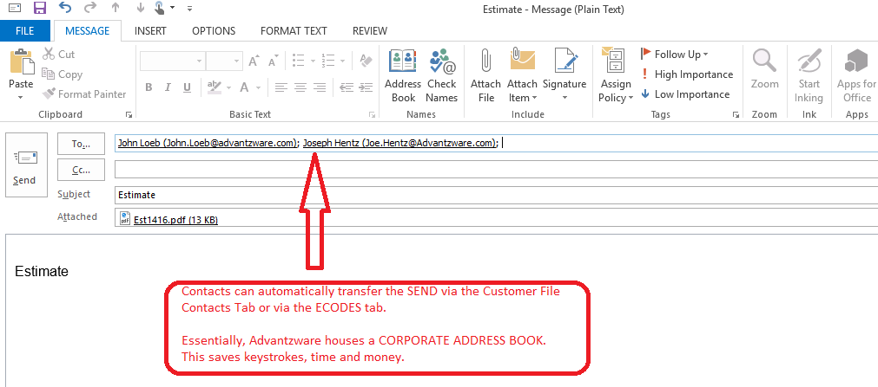

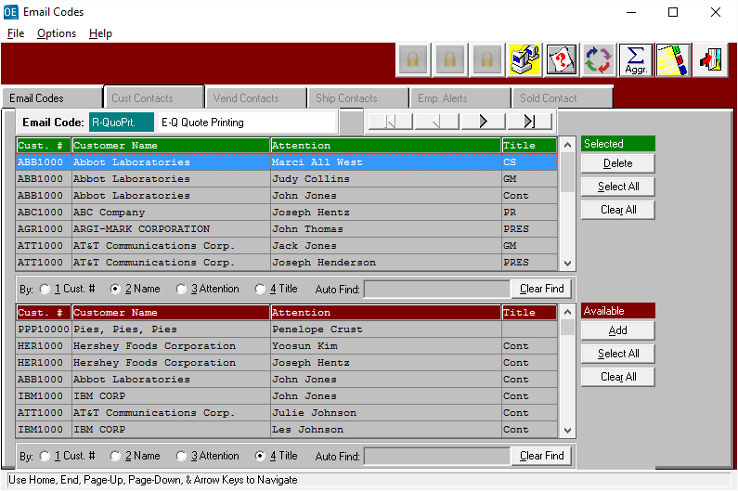

**FOLDING CARTON ESTIMATING OPTIONS - Set Button for Sets & Rigid Boxes - Estimate 1369**

1. Set Button for Assembled or Unassembled.
2. Inventory Control for Assembled & Unitized vs Unassembled Shipped Separately
3. Freight and Packaging Form 0-0 on Inks Pack Tab
4. Consolidated Routings

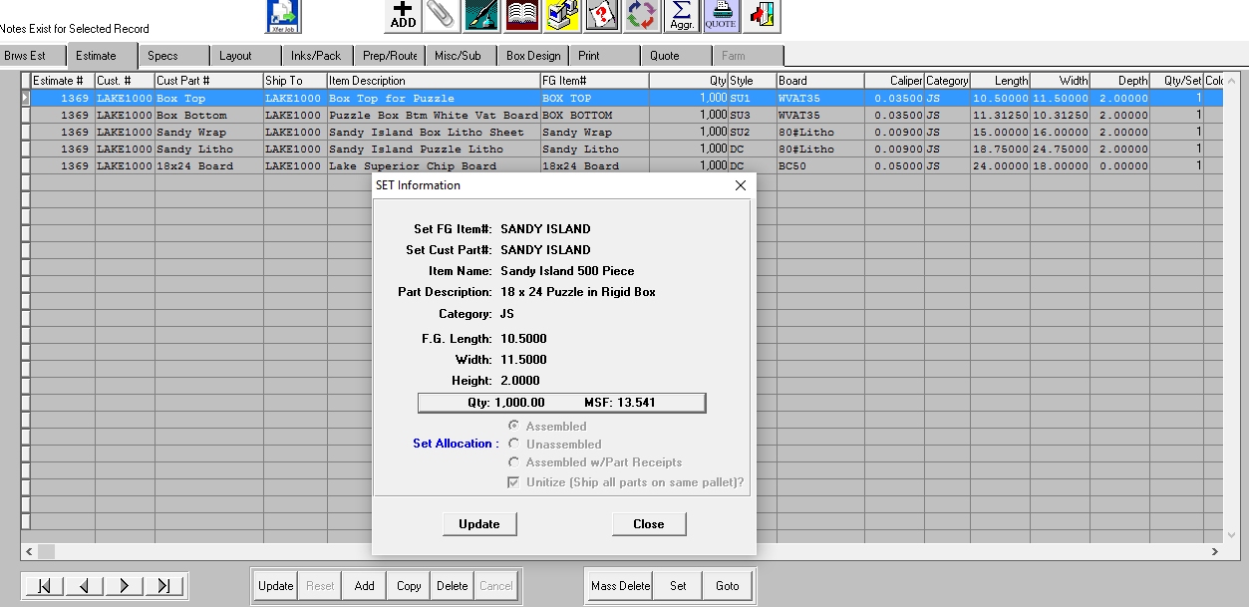

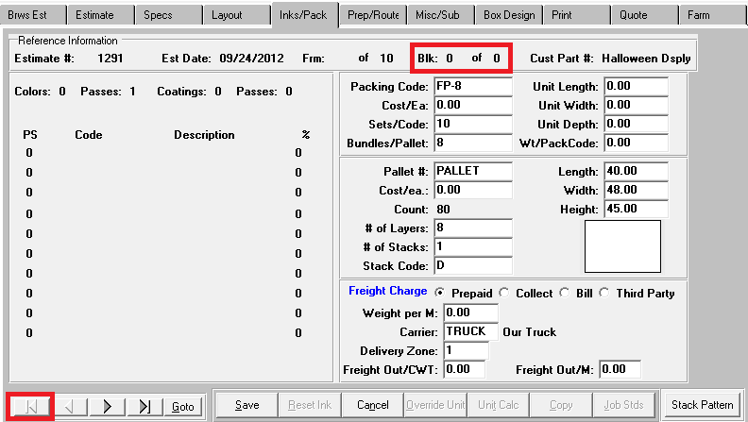

**FOLDING CARTON ESTIMATING COMBO / Tandem Jobs - Estimate 1421**

1. N-K-1 COMBCOST for average cost per item or unique cost per item based on Square Inch.
2. Unlimited Items per Sheet
3. Unlimited Sheets-Forms per Estimate
4. Cost per Sheet for Sheet Fed and Cost per Blank for Blank Fed Machines
5. GOTO button for changing Form, Request, Qty Yield Qty and Die Layout

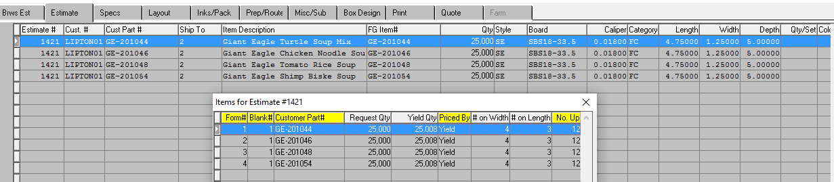

**COMBO / TANDEM LAYOUT TAB - Leaf / Film Button for Each Blank or Form**

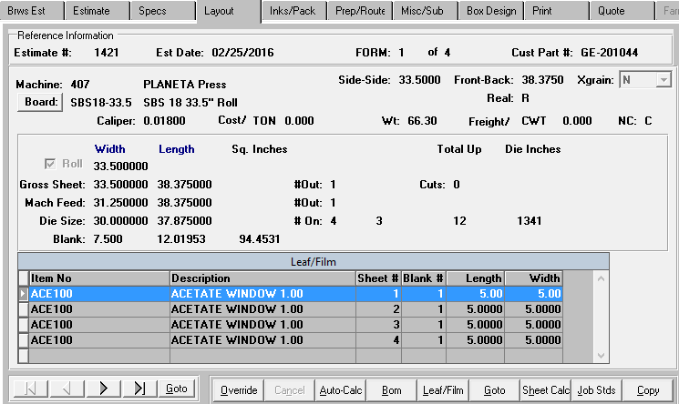

**TANDEM / COMBRO PREP / ROUTING Tab**

1. Shows Separate Prep for Form
2. Shows Separate Routing per Form and Blanks per per Item
3. Import Button to Show Plant and Fountain Changes

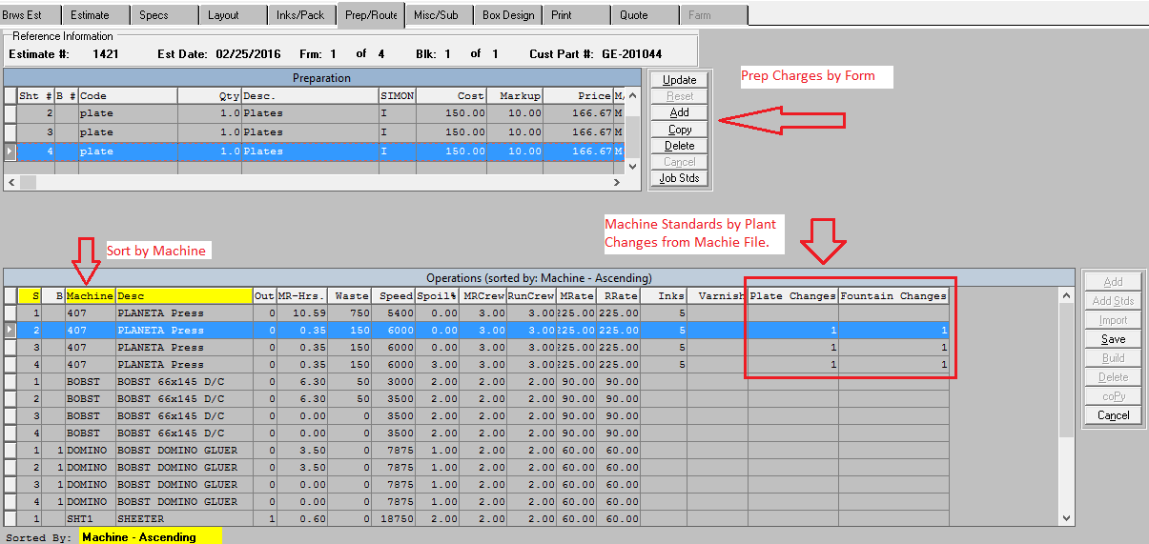

**FOLDING CARTON ESTIMATING - LAMINATION SINBLE FACE - Estimate 1444**

1. LAYOUT Button for Laminating Top Printed Sheets to Single Face Corrugated Paper Rolls
2. BOM Button shows Paper and Adhesive Materials

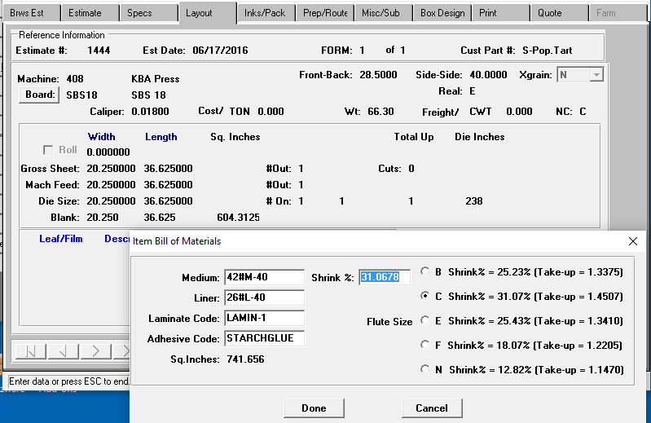

**Routing Tab for Laminating Paper to Sheets**

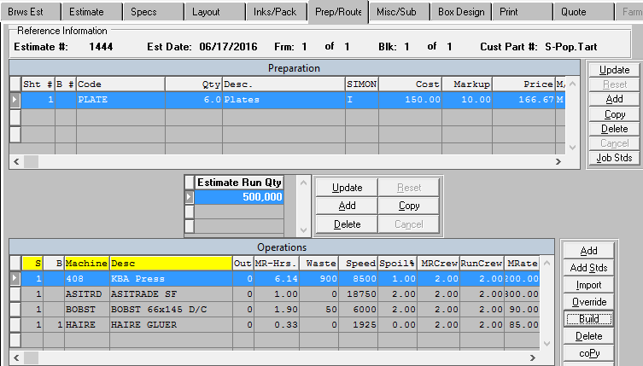

**FOLDING CARTON ESTIMATING - LAMINATION SINBLE FACE - Estimate 1444**

1. Shows Top Printed Sheet & Single Face Paper for Asitrade Laminator

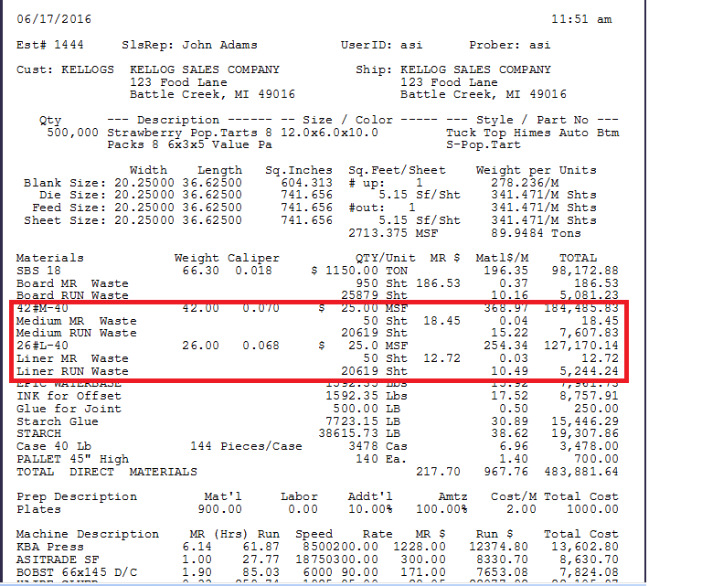

**FOLDING CARTON ESTIMATING OPTIONS - FARM OUTS Estimate 1354**

1. Same Estimate Specifications as Manufactured Except P/M = Purchased
2. Machine Department = FO and FARM TAB Options
3. Layout Tab Defaults Board to Non Chargeable
4. Routing Tab Defaults to Machine with Department FO with No Cost
5. FARM Tab houses Finished Goods Costs by Vendor
6. Eliminating Materials Waste Costs from Farm outs N-K-1 CECPURWAS

**Estimate Tab showing Purchased/ Manufactured Field**

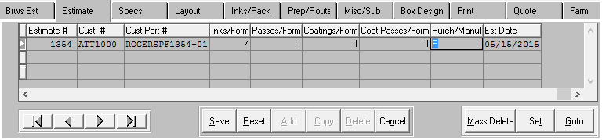

**FARM Tab houses Finished Goods Vendor Cost Matrix**

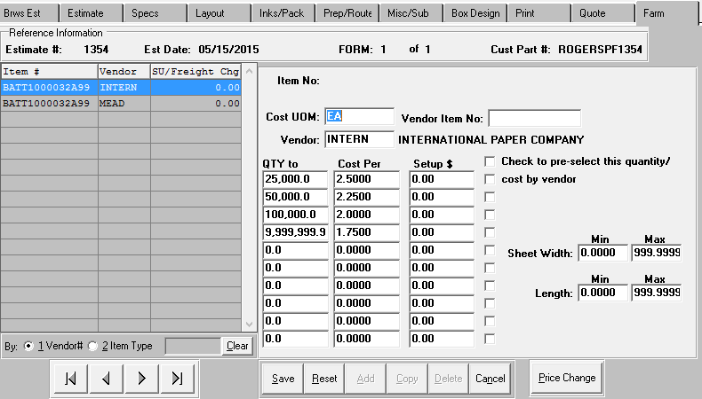

**FOLDING CARTON QUOTE SHEET GENERAL FEATURES** (N-K-1 QuoSheet)

1. Add Quotes for Finished Goods Items without created Quotes
2. Create a Price Sheet for Clients to Order
3. Import Invoices Prices or Quoted Prices

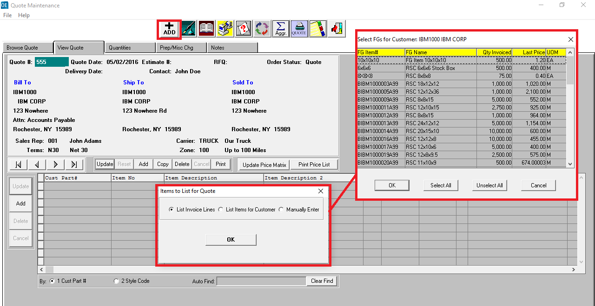

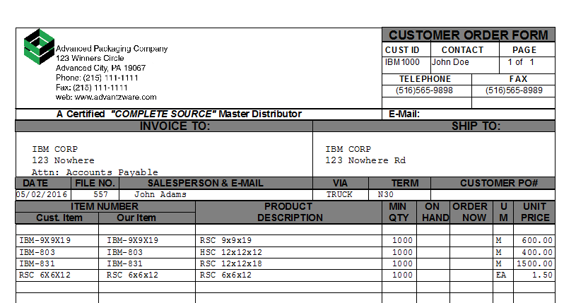

**FOLDING CARTON   
QUOTE GLOBAL PRICE CHANGE GENERAL FEATURES**

1. Updated Quote History Price Increases or Decreases
2. Updated Quote History by Board Code
3. Updates Quote History by Customer
4. Updates Quote History by Customer
5. Raw Material Increases update newly calculated estimates
6. Raw Material Increases do not update Quote History

**Global Quote Price Change**

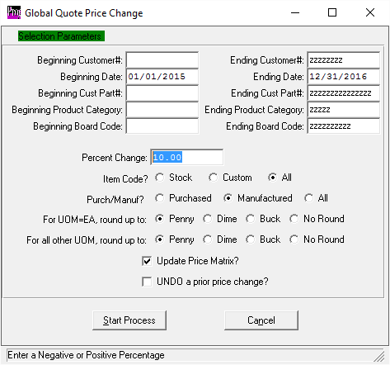

**FILE MAINTENANCE GENERAL FEATURES - Prep, Plates and Dies**

1. Default Prep Master N-K-1 PREPMASTER
2. Default Plate / Print Die Bin Location N-K-1 PREPPLBIN
3. Default Plate GL Account # N-K-1 PrepPLGL
4. Default Cutting Die Bin Location N-K-1 PrePDieBin
5. Default Cutting Die GL Account # N-K-1 PrepDieGL

**Prep File**

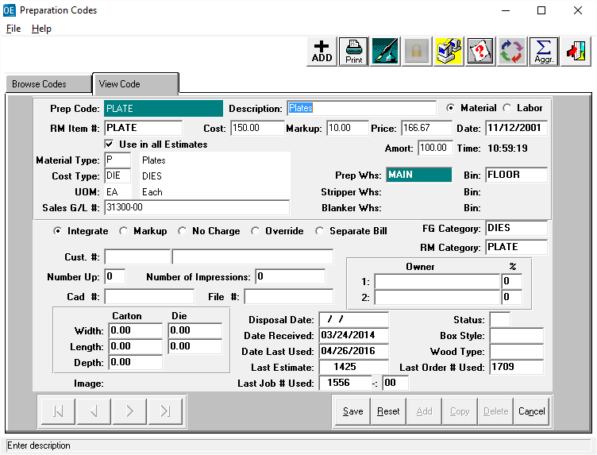

**FILE MAINTENANCE GENERAL FEATURES - Control File Markups**

1. Default Materials in Not Defined by Style
2. Handling Charge Markup for Manufactured Items
3. Handling Charge Markup for Farm Out Items
4. Warehouseing Markups
5. Broker Commission Default
6. Special Markups by Dollor or Percentage
7. Sell Price by Net, Gross or MSF
8. General Selling & Admin (GS&A) Markup Matrix by Material and Labor
9. Options to Show Commissions, Rates and Costs in Full or Factory Costs.

**Estimate Control Tab**

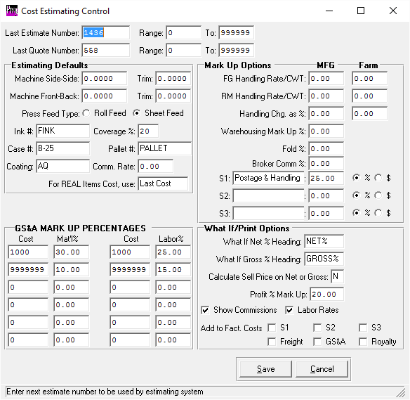

**FILE MAINTENANCE GENERAL FEATURES - CARRIER / TRUCK FILE**

**TRUCK FILE for Freight, Minimim Charge and Truck Routing**

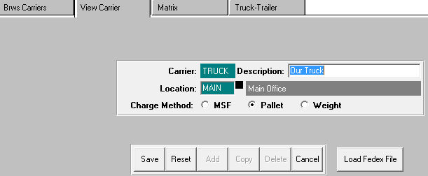

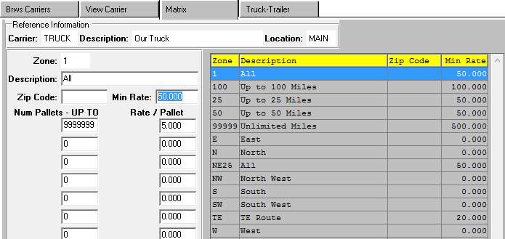

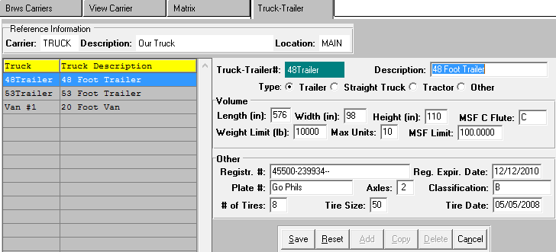

**FILE MAINTENANCE GENERAL FEATURES - Machine File**

**Machine Standards Tab - N-Z-7 for Latest X-Y Matrix Options**

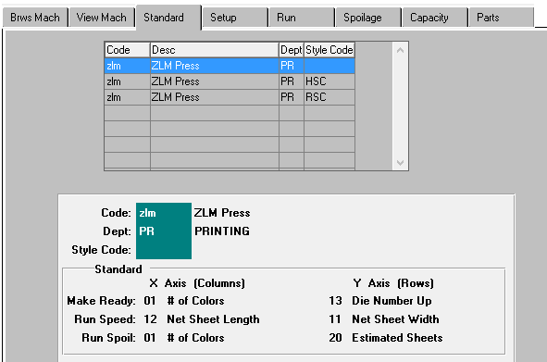

**Machine Parts Tab**

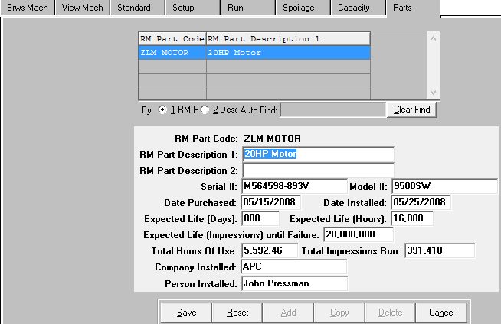

**FILE MAINTENANCE GENERAL FEATURES - STYLE FILE**

1. Style Types B = Boxes, P= Paper, D=Die Cuts
2. Default Blank Dimensions
3. Default Materials and Default Machines

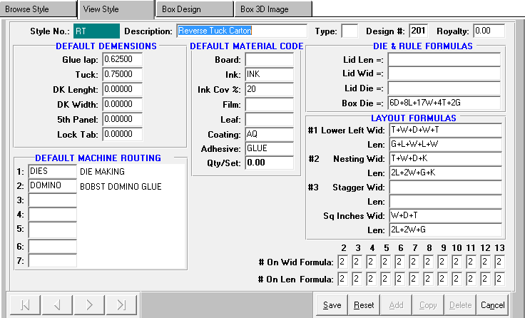

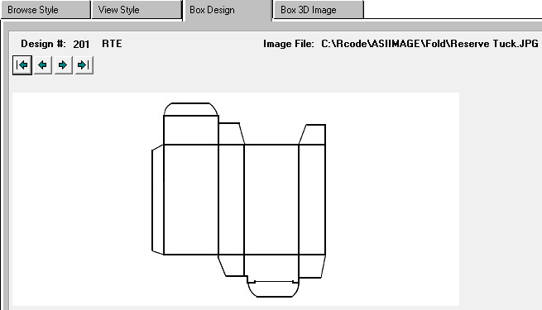

**ESTIMATING REPORTS - Popular Reports**

**E-R-5 Estimates List to Show Unbooked Estimates**

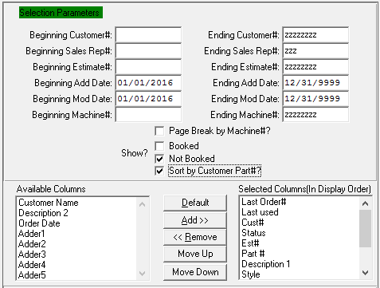

**E-R-7 Prep List by Material Type to Show Old Plates and Dies**

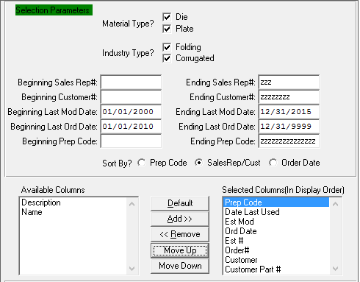

**ESTIMATING REPORTS - Popular Reports**

**E-R-8 Estimates by Size**

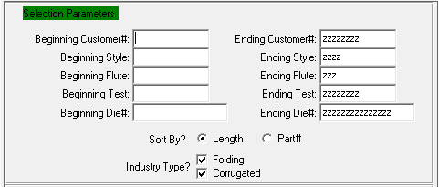

**E-R-8 Quotes Price List**

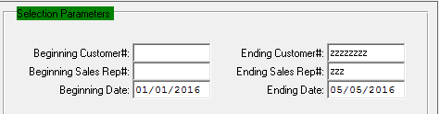

**E-R-10 Estimates List with Multiple Margins**

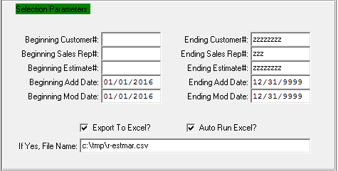

**ESTIMATING STANDARDS REPORT - TO UPDATE ESTIMATE STANDARDS**

**D-R-14 W.I.P Standards Details by Style, Size, etc.**

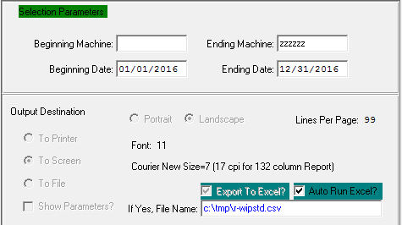

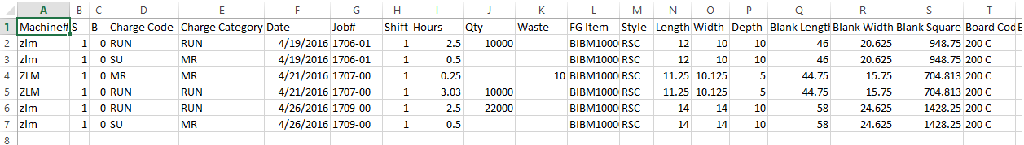

**ESTIMATING - SHEET CALC VIA THE JOB FILE**

1. Estimating and Job File are Identical SHEET CALC program.
2. Job File also Allows to ISSUE immediately to Job

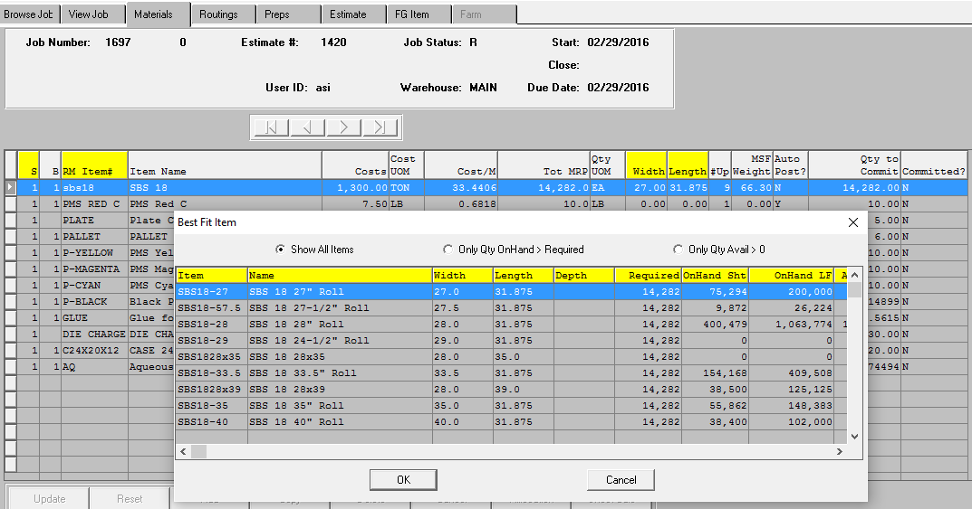

**ESTIMATING - N-K-1 CONTROL PARAMETERS**

1. Search by Descripiton starting with the letters CE for Estimating paratmeters.
2. Search by Descripiton starting with the letters QUO for Quote paratmeters.
3. Click View Control Tab and Press F3 in the light white block for help for a specific parameter.

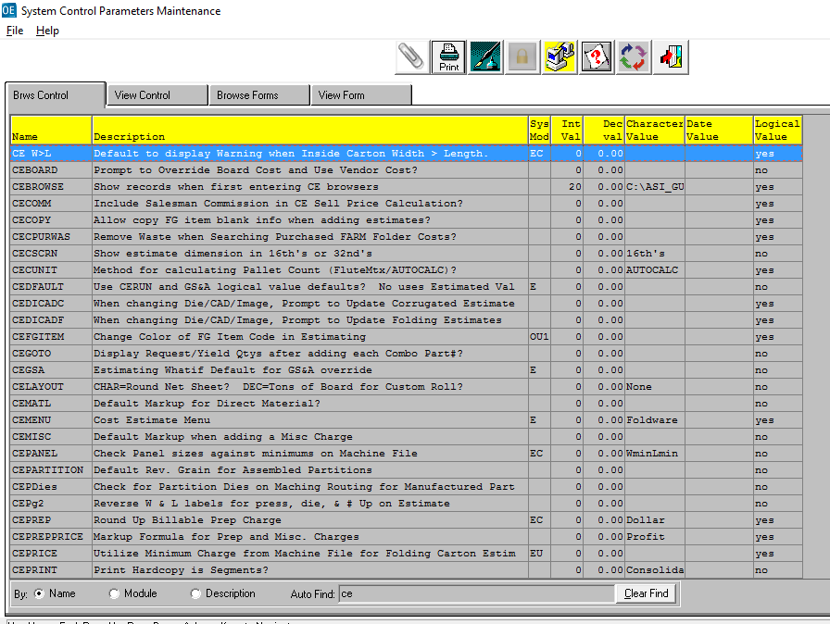

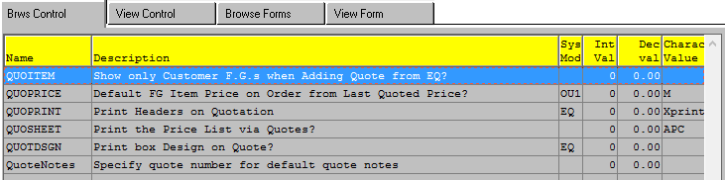

**ESTIMATING - SECURITY by USER ID by CUSTOMER**

1. Limit Access to Only Customers Defined in the Customer Tab of the User ID File.
2. Limit Reporting to Only Customers Defined in the Customer Tab.

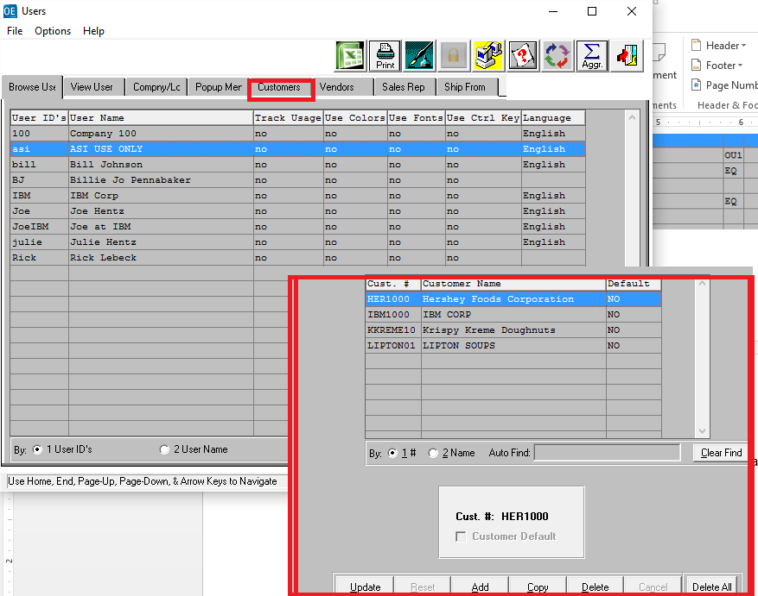

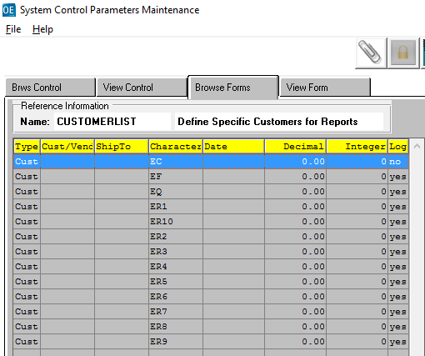

**SYSTEM ADMINISTRATION - N-Z-3 MATERIAL TYPES**

1. Material Types 5 for Case or Pallet Pads
2. Material Type 6 for Case or Pallet Dividers
3. New Material Types for Improved Job Costing
4. New Material Types for Automatic Color Changes on Machine Schedule Board

